結構控制 HW1

1. 依據題目給定的條件，尋找結構週期。

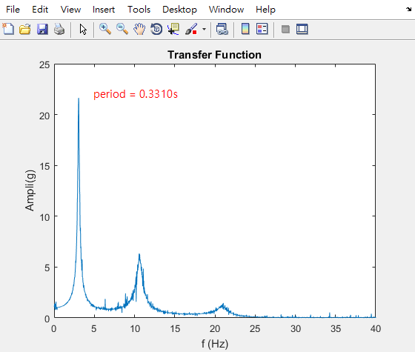

得到題目給的第一模態的週期為：0.3310s

clc; clear; close all;

El50AXBS_fileid = fopen('El50AXBS.txt', 'r');

EL50RFA_fileid = fopen('EL50RFA.txt', 'r');

El50AXBS = fscanf(El50AXBS_fileid, '%f');

EL50RFA = fscanf(EL50RFA_fileid, '%f');

[EL50RFA_freq, EL50RFA_ampl] = fft_improve(EL50RFA, 0.0125);

[El50AXBS_freq, El50AXBS_ampl] = fft_improve(El50AXBS, 0.0125);

transfer_function = EL50RFA_ampl ./ El50AXBS_ampl;

plot(El50AXBS_freq(2 : end), transfer_function(2 : end));

[transfer_function_max, transfer_function_index]=max(transfer_function(2 : end));

1 / El50AXBS_freq(transfer_function_index)

title('Transfer Function');

xlabel('f (Hz)');

ylabel('Ampli(g)');

1. 找到給定的結構週期之後，調整版厚來對應到題目給的週期。

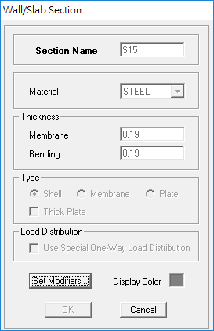

版厚調整為 19 公分。

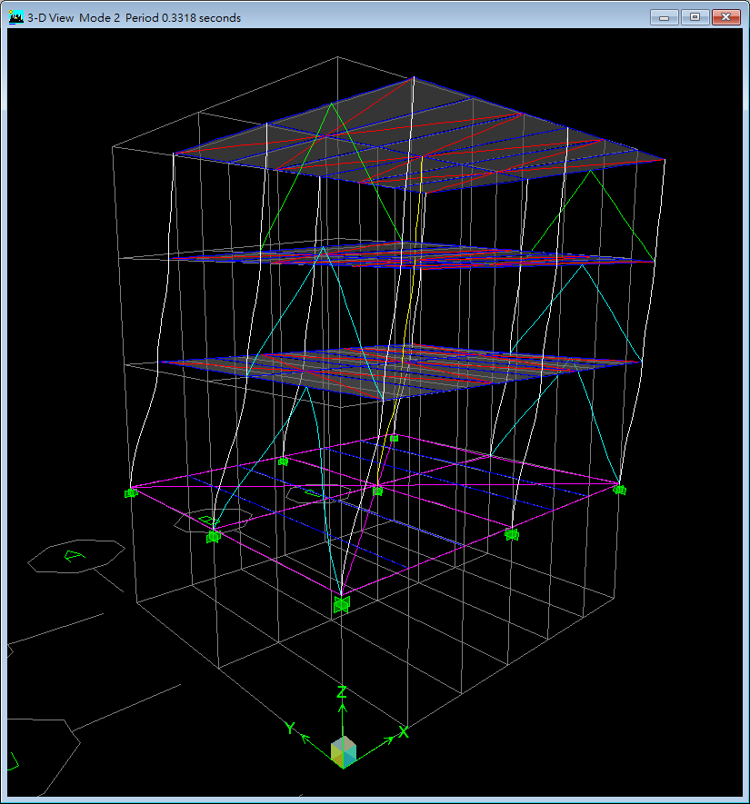

模型週期為：0.3318s

6 個 mode shapes

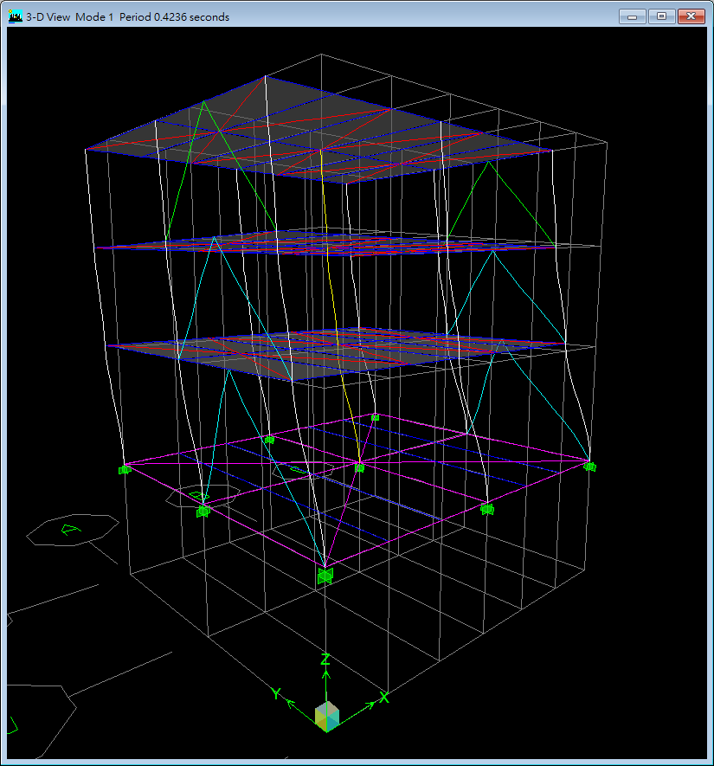

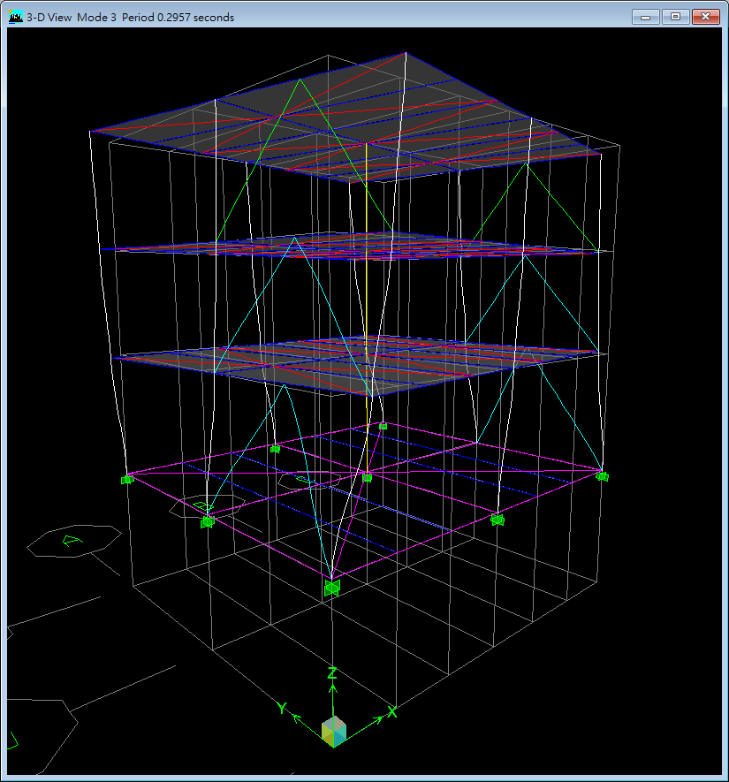 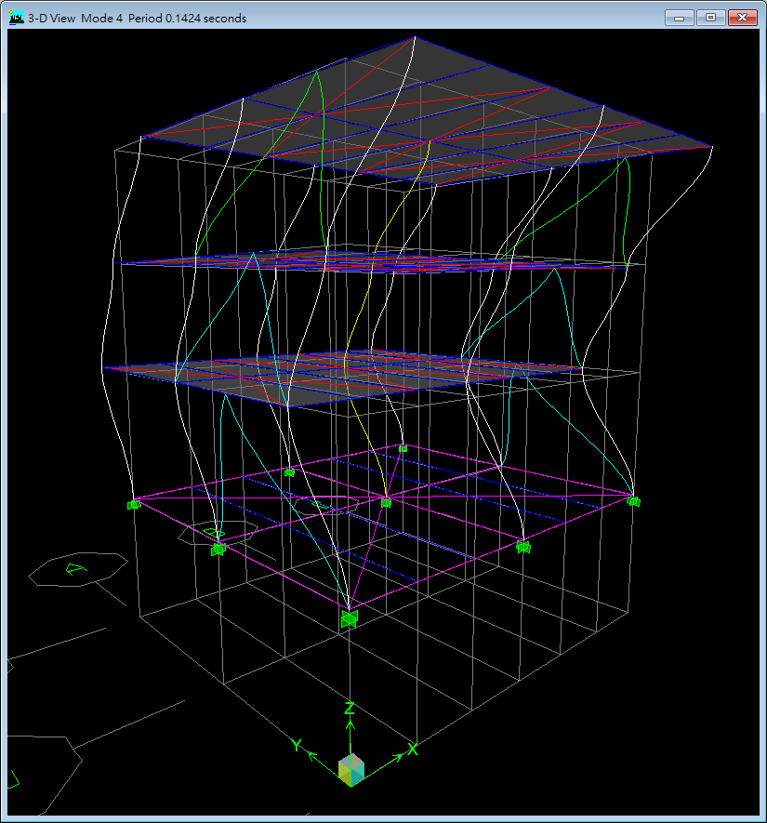 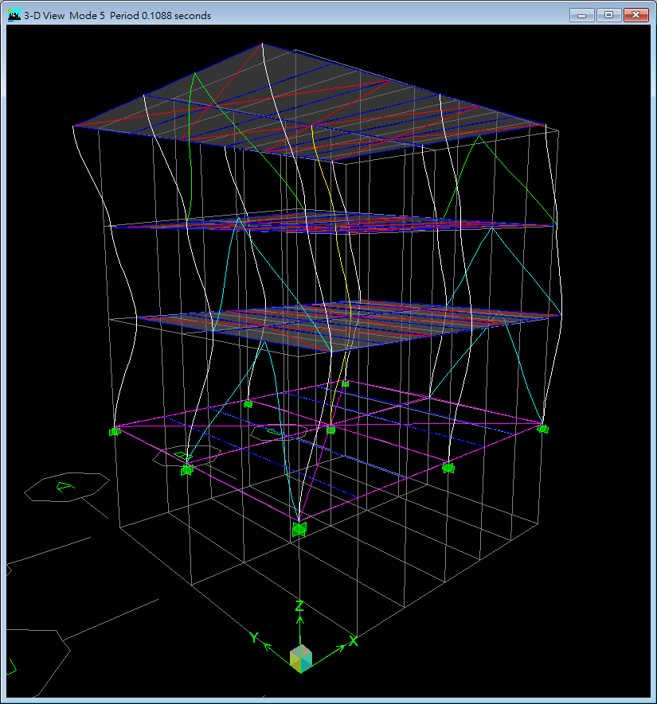 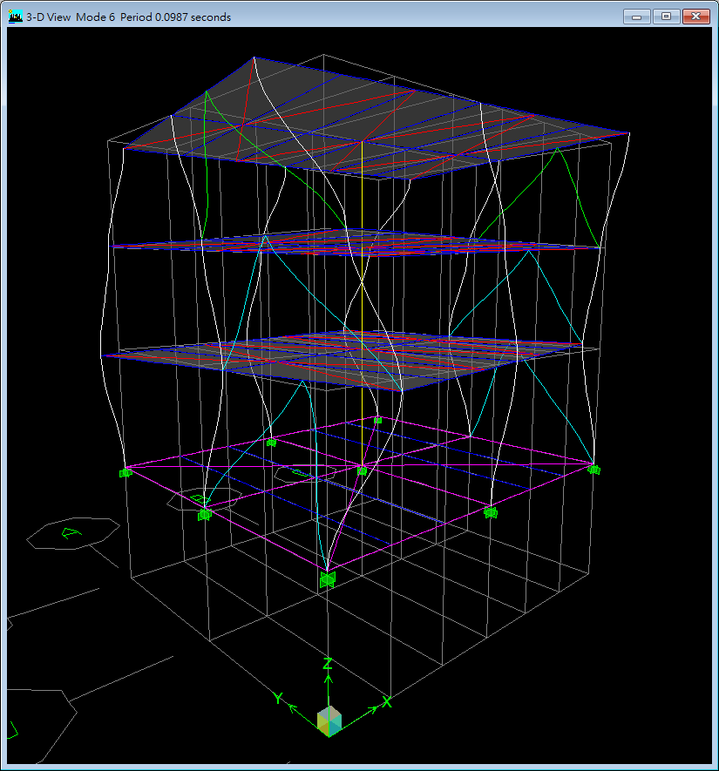

1. 調整完成週期之後，調整模型的阻尼比來對應到題目給的阻尼比。

3%

樓頂位移 Trensfer Function

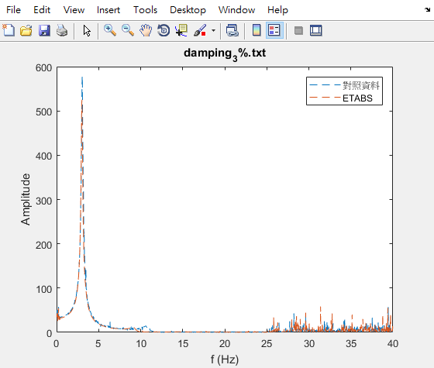

樓頂加速度 Trensfer Function

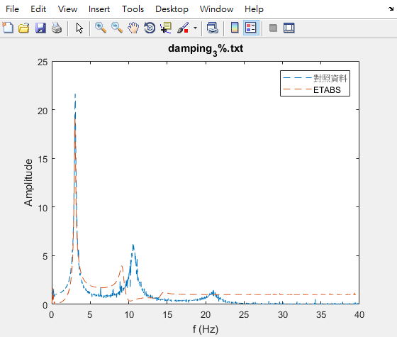

2%

樓頂位移 Trensfer Function

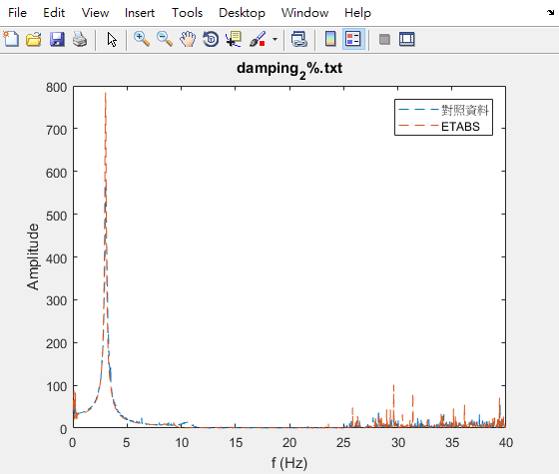

樓頂加速度 Trensfer Function

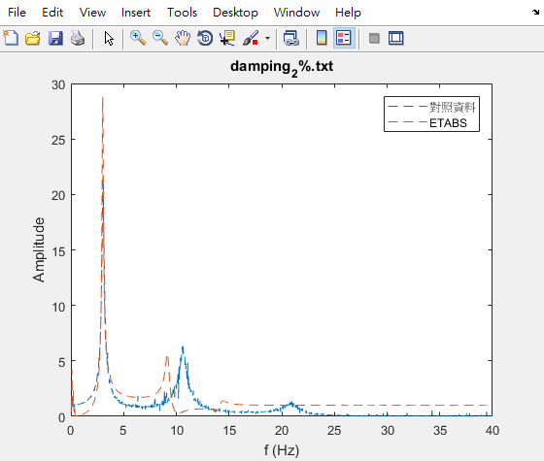

2.7%

樓頂位移 Trensfer Function

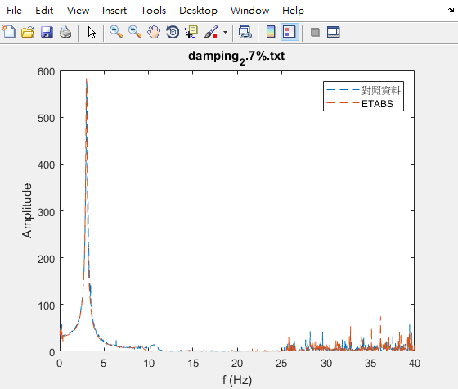

樓頂加速度 Trensfer Function

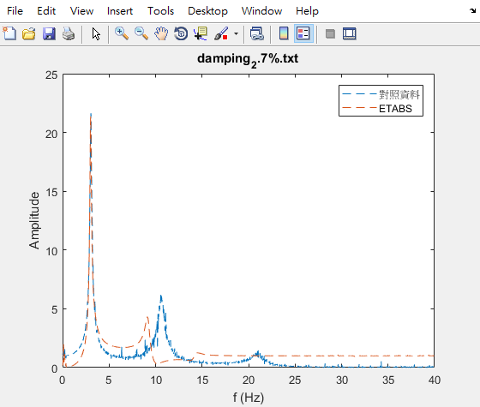

多次試誤後得到 2.7% 的阻尼比最吻合題目給的資料。

function [] = find_damping(*file*)

TIME_COL = 1;

DISP_COL = 2;

ACCEL_COL = 3;

BASE_COL = 4;

El50AXBS_fileid = fopen('El50AXBS.txt', 'r');

El50AXBS = fscanf(El50AXBS_fileid, '%f');

EL50RFA_fileid = fopen('EL50RFA.txt', 'r');

EL50RFA = fscanf(EL50RFA_fileid, '%f');

EL50RFD_fileid = fopen('EL50RFD.txt', 'r');

EL50RFD = fscanf(EL50RFD_fileid, '%f');

damping_fileid = fopen(file, 'r');

damping = fscanf(damping_fileid, '%f %f %f %f', [4 Inf]);

damping = damping';

damping(:, DISP_COL) = damping(:, DISP_COL) * 1000;

damping(:, ACCEL_COL) = damping(:, ACCEL_COL) / 9.81;

damping(:, BASE_COL) = damping(:, BASE_COL) / 9.81;

figure;

plot((1 : length(EL50RFA)) * 0.0125, EL50RFA, damping(:, TIME_COL), damping(:, ACCEL_COL), '--')

figure;

[~, El50AXBS_ampl] = fft_improve(El50AXBS, 0.0125);

[EL50RFA_freq, EL50RFA_ampl] = fft_improve(EL50RFA, 0.0125);

input_transfer_function = EL50RFA_ampl ./ El50AXBS_ampl;

plot(EL50RFA_freq(2 : end), input_transfer_function(2 : end), '--');

hold on;

[damping_freq, damping_ampl] = fft_improve(damping(:, ACCEL_COL), 0.0125);

[~, base_ampl] = fft_improve(damping(:, BASE_COL), 0.0125);

output_transfer_function = damping_ampl ./ base_ampl;

plot(damping_freq(2 : end), output_transfer_function(2 : end), '--');

title(file);

xlabel('f (Hz)');

ylabel('Amplitude');

legend('對照資料', 'ETABS');

figure;

[~, El50AXBS_ampl] = fft_improve(El50AXBS, 0.0125);

[EL50RFD_freq, EL50RFD_ampl] = fft_improve(EL50RFD, 0.0125);

input_transfer_function = EL50RFD_ampl ./ El50AXBS_ampl;

plot(EL50RFD_freq(2 : end), input_transfer_function(2 : end), '--');

hold on;

[damping_freq, damping_ampl] = fft_improve(damping(:, DISP_COL), 0.0125);

[~, base_ampl] = fft_improve(damping(:, BASE_COL), 0.0125);

output_transfer_function = damping_ampl ./ base_ampl;

plot(damping_freq(2 : end), output_transfer_function(2 : end), '--');

title(file);

xlabel('f (Hz)');

ylabel('Amplitude');

legend('對照資料', 'ETABS');

end

clc; clear; close all;

find_damping('damping_2.7%.txt');

*% find_damping('damping_2.5%.txt');*

find_damping('damping_2%.txt');

find_damping('damping_3%.txt');

*% find_damping('damping_2.8%.txt');*

1. 調整完成模型後，進行預測。

NCERB

加速度

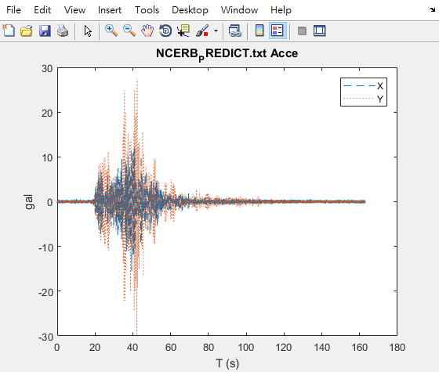

位移

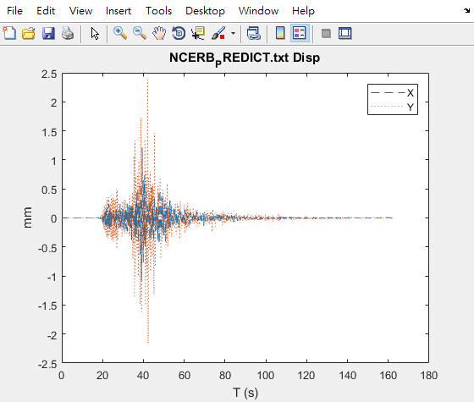

TzuChi

加速度

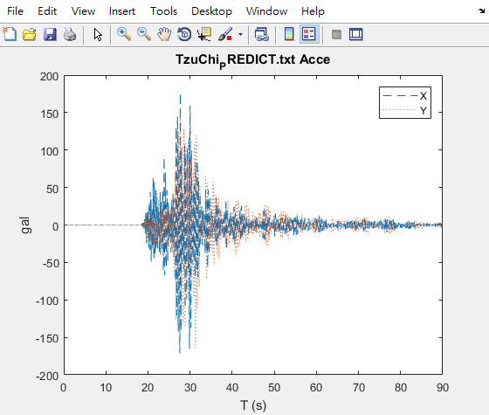

位移

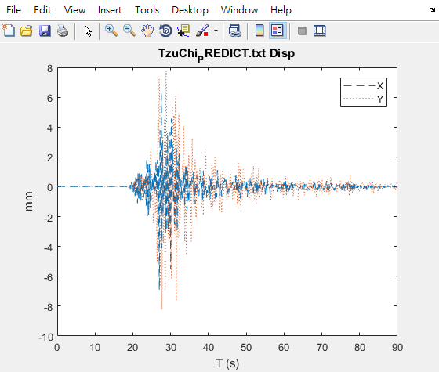

function [] = predict_model(*file*)

TIME_COL = 1;

DISP_X_COL = 2;

ACCEL_X_COL = 3;

DISP_Y_COL = 4;

ACCEL_Y_COL = 5;

damping_fileid = fopen(file, 'r');

damping = fscanf(damping_fileid, '%f %f %f %f %f', [5 Inf]);

damping = damping';

damping(:, [DISP_X_COL, DISP_Y_COL]) = damping(:, [DISP_X_COL, DISP_Y_COL]) * 10;

figure;

plot(damping(:, TIME_COL), damping(:, DISP_X_COL), '--', damping(:, TIME_COL), damping(:, DISP_Y_COL), ':');

title([file ' Disp']);

xlabel('T (s)');

ylabel('mm');

legend('X', 'Y');

figure;

plot(damping(:, TIME_COL), damping(:, ACCEL_X_COL), '--', damping(:, TIME_COL), damping(:, ACCEL_Y_COL), ':');

title([file ' Acce']);

xlabel('T (s)');

ylabel('gal');

legend('X', 'Y');

end

clc; clear; close all;

predict_model('NCERB_PREDICT.txt');

predict_model('TzuChi_PREDICT.txt');

1. Matlab Function Code

function [*frequency*, *amplitude*] = fft_improve(*data*, *time_interval*)

data_length = length(data);

data_fft = fft(data);

data_abs = abs(data_fft / data_length);

data_half = data_abs(1 : fix(data_length / 2 + 1));

data_half(2 : end - 1) = 2 * data_half(2 : end - 1);

amplitude = data_half;

frequency = 1 / time_interval * (0 : fix(data_length / 2) ) / data_length;

end